

**Virtual Twinning to Analyze/Predict Circuit Failure**

Fall 2024

College of Engineering and Computing

Department of Electrical and Computer Engineering

ECE 448: Senior Design

Advisor – Mark Scott, PhD

Advisor – Peter Jamieson, PhD

**Caroline Van Neste**

**Claire Hopfensperger**

**Jess Grady**

**December 6, 2024**

## **Table of Contents**

## 

**1 Introduction 3**

**2 Project Background 3**

**3 Project Research 5**

3.1 RC Low-Pass Filter 5

3.2 State-Space Model 5

3.3 Failure Conditions of Capacitors 7

**4 Solution Process 7**

4.1 Developing the Low-Pass Filter 7

4.1.1 Designing the Low-Pass Filter 7

4.1.2 Building the Low-Pass Filter 9

4.2 Designing the Test Setup 11

4.2.1 Auxiliary Equipment 11

4.2.1.1 Oscilloscope 11

4.2.1.2 Function Generator 12

4.2.1.3 Computer 12

4.2.2 Safety Procedures 12

4.2.3 Redesigning the Perfboard Setup 14

4.3 Taking Measurements 15

4.4 Developing the Model 15

4.4.1 Choosing the State-Space Model 15

4.4.2 Developing the State-Space Model 16

4.5 Methodology of Failing Capacitors 17

**5 Final Results 17**

**6 Future Work 18**

**7 Team Reflection 19**

**8 Conclusions 19**

**References 21**

**Appendix A: Procedure for taking measurements of an electrolytic capacitor. 23**

**Appendix B: Procedure for artificially aging an electrolytic capacitor with heat. 24**

## 

## **1 Introduction**

We heavily rely on electronic circuits in every part of our daily lives. Most items we interact with contain electronic circuits, both digital and analog. Because of our dependence on electronic circuits, ensuring their correct and safe functionality and being able to determine when they might fail is imperative. Due to the discrete nature of digital signals which simplifies modeling, many advanced tools exist for digital circuit simulation, analysis, and failure detection. Analog circuits, on the other hand, require more complex models in order to accurately simulate and analyze their continuous and varying behavior under differing conditions. If there were an accurate and reliable way to test analog circuits and predict when they may fail, potential consequences such as loss of income or even as extreme as loss of life can be avoided.

This project’s goal is to create an accurate and reliable “digital twin”, or virtual model and simulation, of a resistor-capacitor (RC) low-pass filter to analyze the contained capacitor’s health, ascertain what point in its lifespan the capacitor is at, and further predict when the capacitor will fail. We hope that by developing a thorough digital twin of the capacitor in an RC low-pass filter for capacitor health monitoring, our work could be the basis for affordable and more complex health monitoring and failure prediction systems, saving systems from extended maintenance downtime and ensuring that failures are identified before they happen.

In this report, we first explain the background of the project (*Section 2 Project Background*), expanding on health monitoring techniques, what a digital twin is, and previous work done by Miami University senior capstone students as well as the related research. Next, we go through our research we executed to establish our foundation of knowledge for this project (*Section 3 Project Research*). Next, we explore the steps we went through to work toward our project goal, including alternative solutions and design decision explanations (*Section 4 Solution Process*). Finally, we analyze our project results of what we have achieved this semester (*Section 5 Final Results*) and reflect on our accomplishments and goals for next semester (*Section 6 Future Work*, *Section 7 Conclusions*).

## **2 Project Background**

Health monitoring and failure detection are important to ensure the reliable and safe operation of electronic systems. Traditionally, health monitoring is done by constantly surveying the system with physical sensors and manual inspections [1]. While this method of health monitoring allows for real-time measurements, it does not always enable real-time or in-depth analysis, and it may require more expensive equipment and more time-consuming implementation [1]. To combat the disadvantages of traditional health monitoring, the research space has been exploring the benefits of utilizing statistical analysis, artificial intelligence, machine learning, control systems, and more techniques for pattern identification that would allow for real-time monitoring, analysis, and failure detection. One specific methodology being explored is using a digital twin of the system as explained by Bofill [1].

A digital twin is a simulated model of a physical system. The digital twin contains detailed information about the physical system’s behavior at any point in its lifespan [1]. By comparing the physical system to its digital counterpart, slight differences can be detected, allowing for early failure detection and prediction. The digital twin method enables more precise measurements than traditional health monitoring methods [1].

In the past two iterations of this capstone project, the previous groups worked to create models of a buck converter and a boost converter, both commonly used voltage converters in power electronics, for capacitor health monitoring and failure detection. One group utilized a Brute Force Algorithm to match the experimental data to the correlating model of a boost converter [2], and the other group used state space representation to create their digital twin model of a buck converter for graphical data comparison [3]. They compared experimental and ideal data to predict capacitor health based on changes in the capacitor’s ripple voltage. For our project, we wanted to reduce the complexity of the system under test (SUT) so that we could characterize the digital twin development process and better understand the basic principles of using a digital twin for capacitor health monitoring.

Similar to the previous two capstone project groups, we will continue to study the lifespan of the aluminum electrolytic capacitor (AEC). AECs’ performance is greatly affected by aging, and since they are widely used in power electronics and other systems, they are often one of the main causes of system failure. Specifically, AECs are responsible for about 30% of power converter failures [4]. In power electronics, a single AEC or a bank of AECs is used, and when one capacitor fails, the entire system can malfunction. One method to ensure reliable system performance is replacing all of the included capacitors [5]. By developing a cost-effective and reliable method of determining the health of an AEC, we can help companies avoid costly mass capacitor replacements by pinpointing when specific capacitors need to be replaced to avoid system malfunctions or failures and increase product safety margins.

## **3 Project Research**

In this section, we explain the topics we researched in order to gain knowledge and build a better understanding of these topics to advance our project. We investigate what an RC low-pass filter is, the general structure of a state-space model, and the failure conditions of capacitors.

### **3.1 RC Low-Pass Filter**

Low-pass filters are commonly used in a large variety of electronic circuits as their design is simple and easily implementable. The most basic type of low-pass filter is the RC low-pass filter, and we will be using this filter as our SUT.

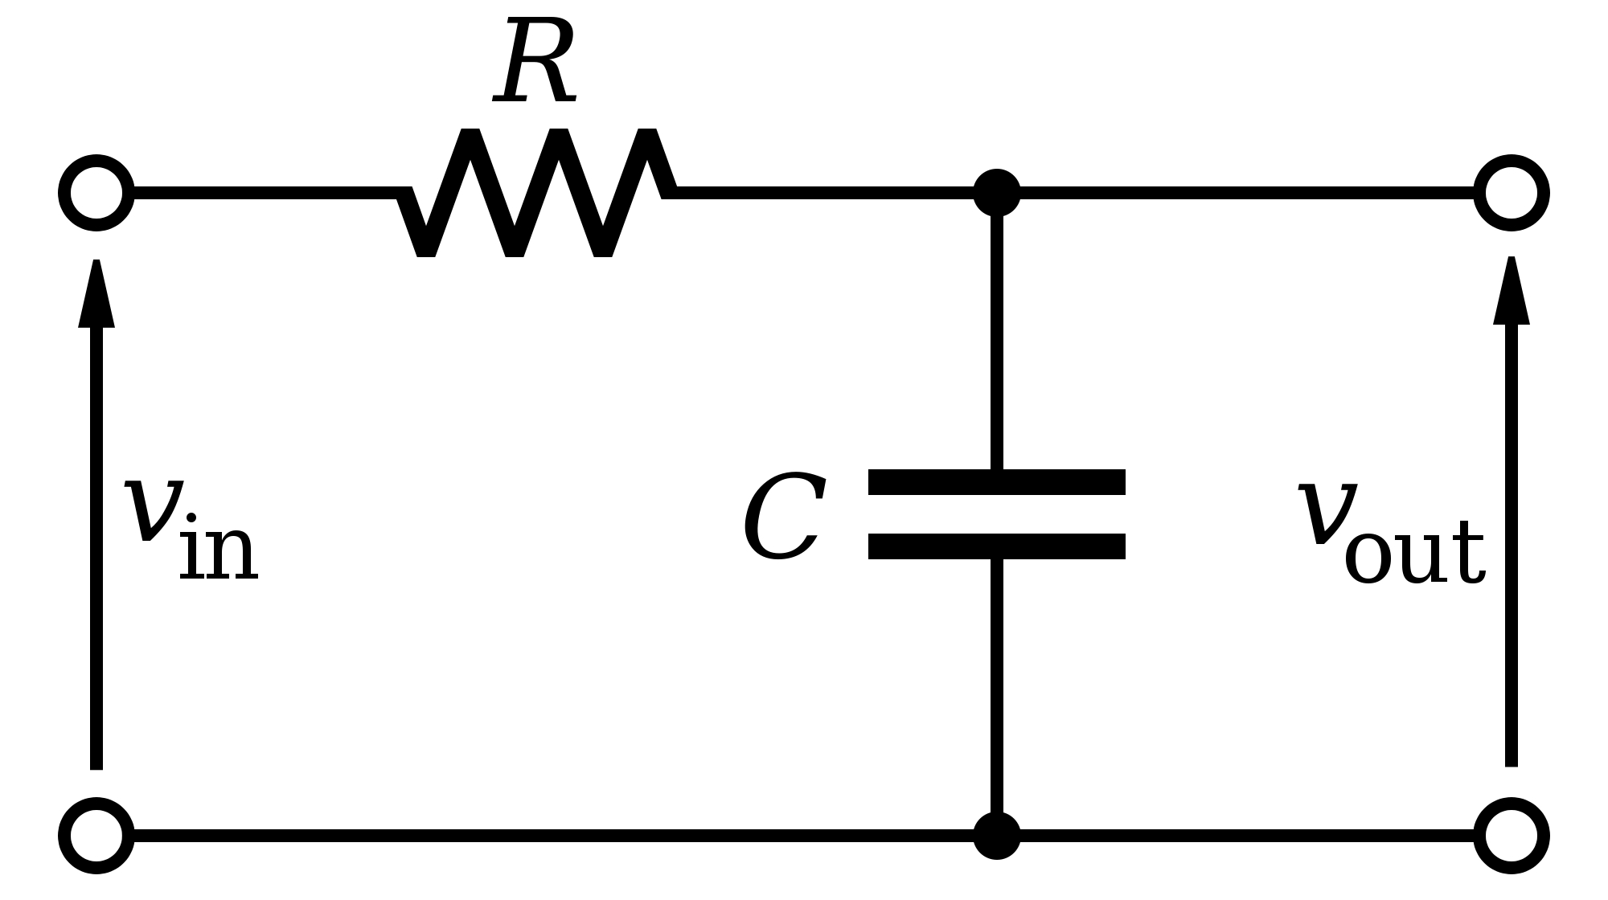

Figure 1: A schematic of an RC low-pass filter (from [6]), the project SUT.

The RC low-pass filter shown in Figure 1 is relatively simple because it only includes a voltage source, a resistor, and a capacitor. The simplicity of the circuit design allows us to start with a basic circuit model and build up from this first-principle starting point

A lowpass filter allows signals to pass through below a specific frequency, also known as the cut-off frequency, by applying high attenuation to the frequencies above it [7].

|  | $f_{c}=\frac{1}{2π × R × C}$ | (1) |
| --- | --- | --- |

The cut-off frequency, fc, is determined by the values of the filter’s equivalent resistance and capacitance as seen in(1). When we build our lowpass filter, we first determine the cut-off frequency which then allows us to determine our resistor and capacitor values (*see Section 4.1.1 Designing the Low-Pass Filter*).

### **3.2 State-Space Model**

Our digital twin relies upon an accurate transient model of the RC low-pass filter circuit. We have decided to model our circuit with a simple state space model. The general form of a state space model is described below. Middlebrook et al. [11], provided us with a process that we used for our similar derivation.

|  |  | (2) |
| --- | --- | --- |

For a state space model, we first need to represent the circuit as a state ***x*** in the form of (2) where each element *x1, x2, …, xm* represents a part of the circuit with memory. Linear Electrical circuits only have two components with memory capacitors, and inductors. We say these components have memory because the voltage across a capacitor and the current across an inductor cannot change instantaneously, and therefore these values need to be recorded in the state. With this state *x*, we now must consider how the state changes in relation to the current state and the current input to the circuit.

|  |  | (3) |
| --- | --- | --- |

This is then written in the form of (3) where A is a square matrix, B is a column vector, and u(t) is the scalar input of the circuit. Lastly, consider the output of the circuit *y*.

|  |  | (4) |
| --- | --- | --- |

This is written in the form of (4) where C is a row vector and D is a scalar. With this model built, there are many packages in languages such as MATLAB that allow for simulation of a state space model.

### **3.3 Failure Conditions of Capacitors**

AEC failure is defined as the capacitance decreasing by 20% and/or the equivalent series resistance (ESR) doubling [5]. Once we develop the digital twin, we plan to use this criterion in order to determine if the capacitor under test is near or in failure.

Alternatively, we could develop a series of root mean square (RMS) voltage, ripple voltage, and frequency limits with respect to time. These RMS values would be determined by either some standard, such as MIL-STD-704 [8], or the rated voltage and frequency of other components.

## **4 Solution Process**

In this section, we explore the research process we went through this semester to advance our capstone project. The main steps are (1) developing the low-pass filter, (2) designing the test setup, (3) taking measurements, (4) developing the model, and (5) failing capacitors.

### **4.1 Developing the Low-Pass Filter**

As discussed in *Section 3.1 RC Low-Pass Filter*, we used an RC low-pass filter as our SUT due to its simplicity, which allows us to build a basic circuit model. Some alternative options for our SUT were a buck converter or boost converter, which are simple and widely used power converters. We chose the low-pass filter over the power converters because we wanted an even simpler circuit for our digital twin development. Using a simpler circuit allows us to more reliably determine what factors influence system behavior and performance. We believe that with this approach, we could make an accurate and reliable model of the low-pass filter. Then, we could use it to develop more advanced models of power converters.

#### **4.1.1 Designing the Low-Pass Filter**

Before we could build our low-pass filter, we needed to decide how we wanted to design our filter. In order to make the design decisions of resistor and capacitor values, we first had to decide what cut-off frequency we wanted our low-pass filter to have. We decided that our cut-off frequency should be 10 kHz for several reasons: (1) A 10 kHz cut-off frequency is easy to achieve with common and small resistor and capacitor values, (2) 10 kHz is a relatively low frequency but still high enough that we can observe alternating current (AC) dynamics, (3) we have access to equipment that is capable of providing and measuring signals at 10 kHz, and (4) we run a lower risk of injury when operating at 10 kHz and 5 V than if we operate at higher frequencies or voltages.

Once we decided on our cut-off frequency value of 10 kHz, we then needed to determine what resistor and capacitor values to use. To do so, we used (1) and tested different variations of resistor and capacitor values to find a combination that we thought was reasonable. We ultimately decided on values of C = 100 nF and R = 160 Ω. We also decided to use two 320 Ω resistors in parallel to achieve the 160 Ω equivalent resistance because 320 Ω resistors are readily available. Notably, when solving for R with fc = 10 kHz and C = 100 nF, we get a resistance of about 159 Ω, but we are not concerned about rounding to 160 Ω given the varying tolerances of the available resistors.

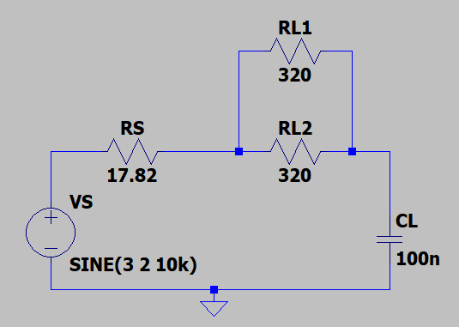

Figure 2: LTspice model of our low-pass filter circuit with two 320 Ω resistors (RL1, RL2) in parallel, a 100 nF capacitor (CL), a source voltage (VS(t) = 3 + 2sin(2 * π * (10 kHz) * t) V), and a source resistance (17.82 Ω).

Once we chose the values for the resistors and the capacitor that would be in our low-pass filter, we ordered our circuit components [9, 10] and designed our circuit in LTspice, as seen in Figure 2, to have a reference circuit and also the ability to simulate the voltage and current behavior of the filter.

We decided that the source voltage would be a 2 V amplitude sinusoidal wave with a 3 V direct current (DC) offset so that the voltage alternates between 1 V and 5 V. We did not want the source voltage to go below 0 V because our capacitor is polar, so sending a negative voltage through it will damage it. We also decided to limit our maximum source voltage to 5 V because it was within the operating voltages allowed for our capacitor of 100V maximum, and would safely operate at this voltage without running risk to anyone taking measurements. We generate our source voltage using a Tektronix AFG 3022B dual-channel Arbitrary Function Generator from the ECE 493 laboratory.

|  | RSource = (VFunctionGenerator/VS  - 1) * RL | (5) |
| --- | --- | --- |

The source resistance was experimentally determined to be 17.82 Ω using (5). We expected it to be closer to 50 Ω, but it was different because we operate the signal generator in High Impedance (High-Z) mode.

#### **4.1.2 Building the Low-Pass Filter**

We first built our low-pass filter on a perfboard, or perforated circuit board, so that we can solder the components together in order to ensure more secure connections than if we only built our filter on a breadboard. A breadboard was acceptable for the initial mockup of the circuit and to ensure that everything was connected correctly, but then building it on the perfboard ensured that there would be minimal measurement errors from loose connections. Secure component connections were an important consideration for our setup because secure connections would allow us to take more reliable measurements.

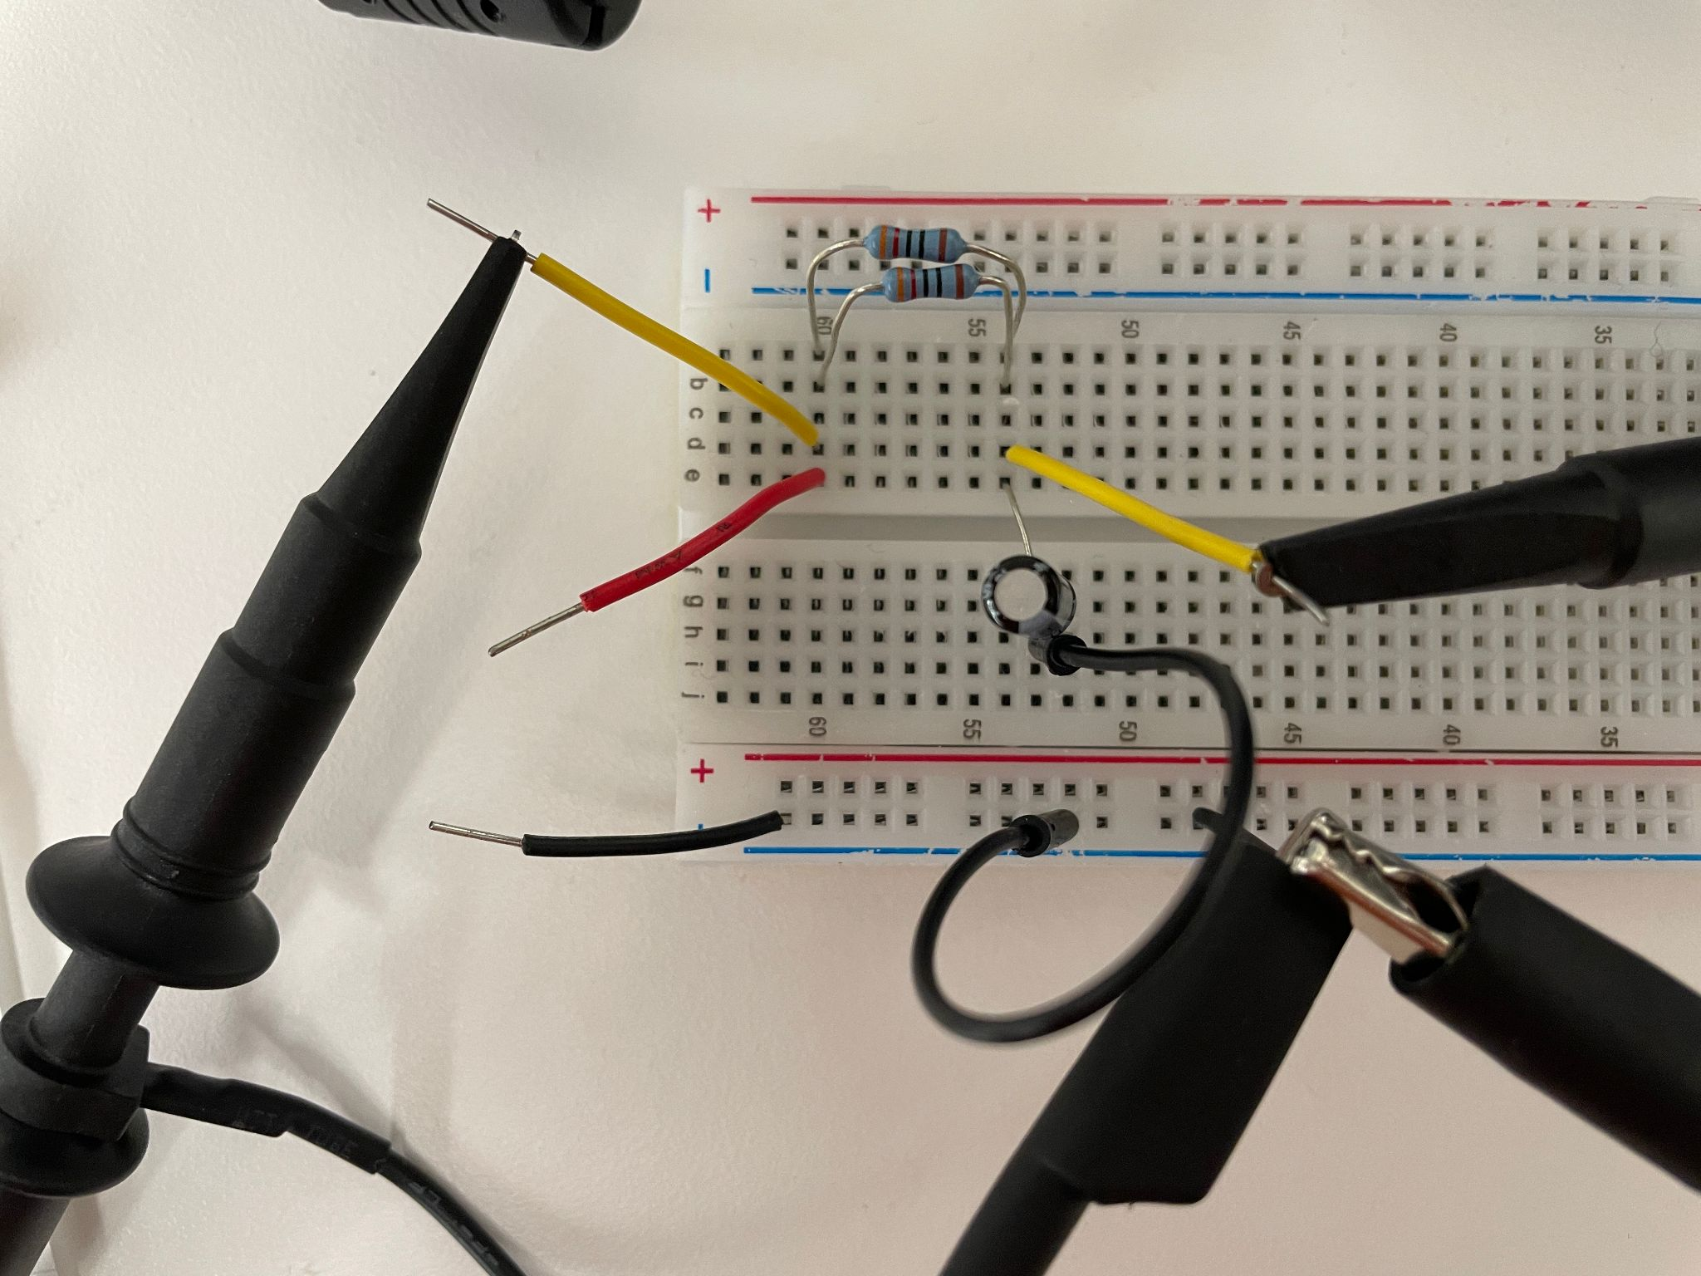

Figure 3: Low-pass filter built on breadboard. Red wire is voltage input, black wire is ground, and yellow wires are for the oscilloscope probes to reach the signals.

We first built our circuit on a breadboard, as seen in Figure 3, to verify that the components we ordered worked in our circuit design.

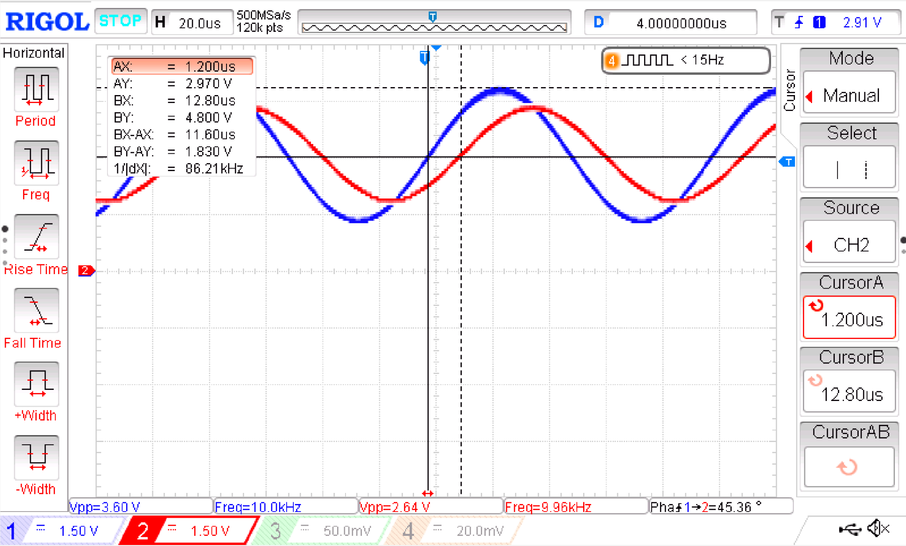

Figure 4: Oscilloscope capture of breadboard low-pass filter on perfboard (Figure 3) source voltage (channel 1) and capacitor voltage (channel 2).

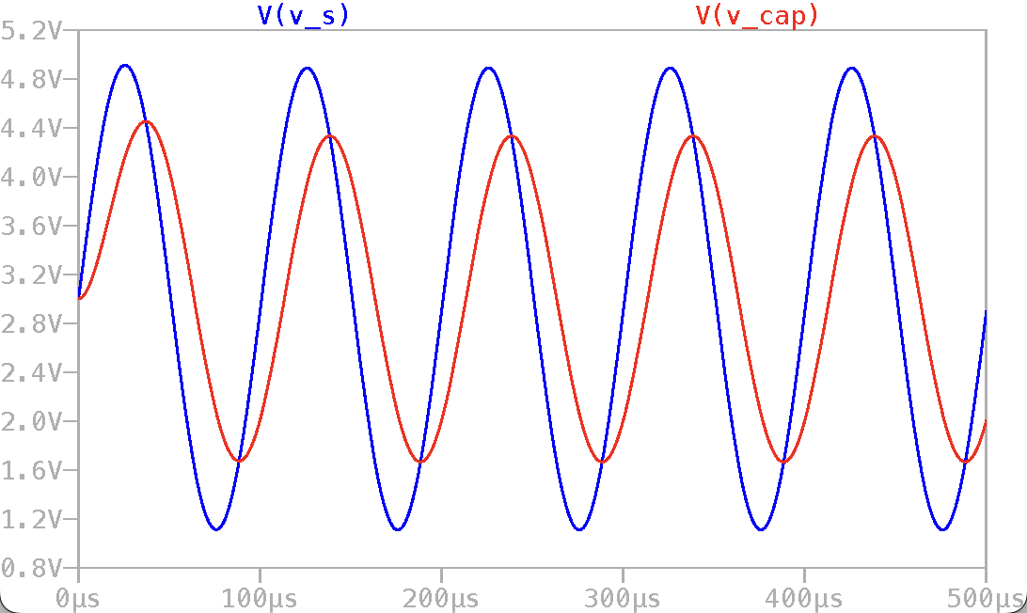

Figure 5: LTspice simulation of low-pass filter (Figure 2) source voltage (dark blue line) and capacitor voltage (red line).

To ensure our breadboard low-pass filter functioned as expected, we compared the source and capacitor voltage waveforms of our LTspice model and our physical filter. The behavior and shape of the breadboard filter voltages in Figure 4 closely resemble the LTspice model voltages in Figure 5 with minor differences that we can attribute to real-world environmental factors and potentially insecure connections between the components and connecting wires in the breadboard. These minor differences were the reason that we decided to take all final measurements from a circuit soldered onto perfboard.

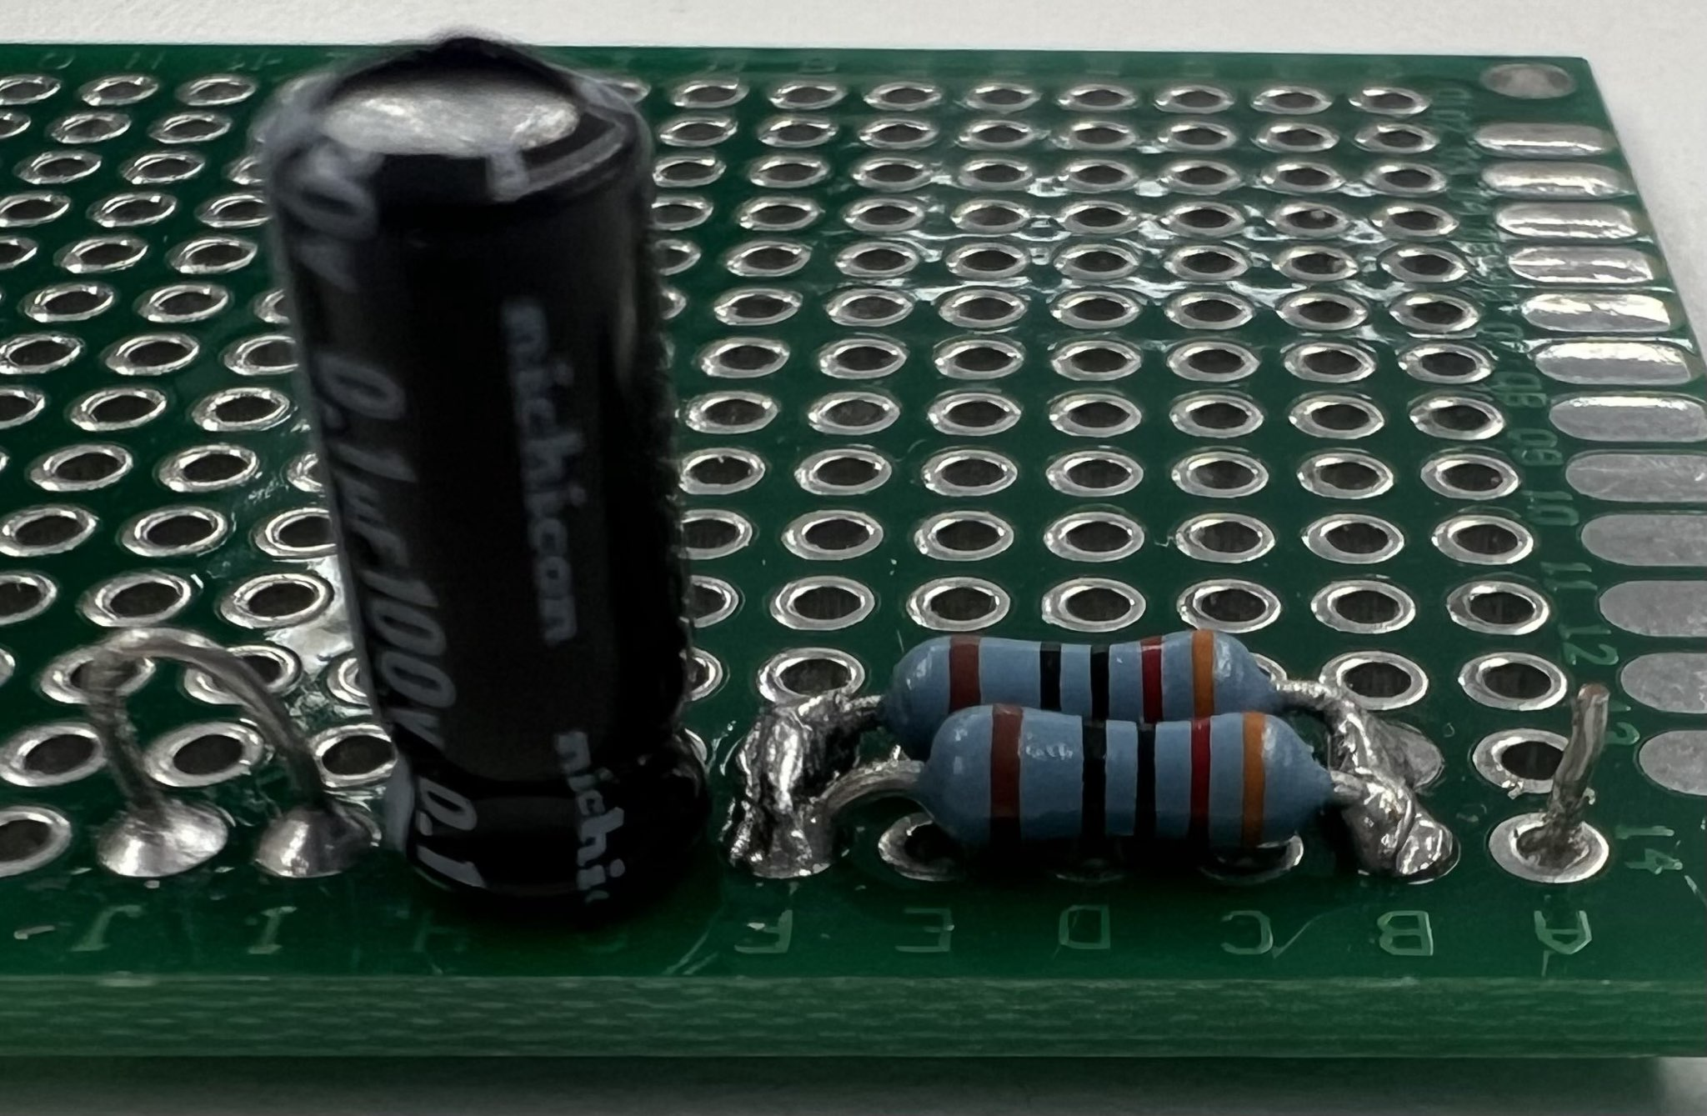

Figure 6: First assembled test low-pass filter circuit.

Because the breadboard low-pass filter functioned as expected, we felt comfortable moving forward with soldering components together on a perfboard, as seen in Figure 6. The perfboard circuit is the same design as in Figure 2and Figure 3, but we left a loop on the left and a test point on the right to allow for probe connectivity for our function generator and oscilloscope probes. The build in Figure 6 was the first iteration of our perfboard low-pass filter, and we went on to build another variation for further testing purposes.

### **4.2 Designing the Test Setup**

Our initial testing setup was our low-pass filter soldered onto a perfboard with attachment points for our probes, as seen in Figure 6.

#### **4.2.1 Auxiliary Equipment**

We used several essential tools to support our experiments, including an oscilloscope for waveform visualization, a function generator for signal input, and a computer for data collection, analysis, and simulation.

##### **4.2.1.1 Oscilloscope**

We used a Rigol DS1054Z Digital Oscilloscope, which has 4 available channels, to take readings with a 50 MHz range and can sample at up to 1 GSa/s to ensure that we had as much data as possible for analysis and processing. It also had features to allow us to export the waveforms being seen/captured to a USB drive connected to the oscilloscope as a screen capture or as a comma-separated value (CSV) form. It also gave us the ability to connect it directly to a computer and pull data in real-time from the oscilloscope.

##### **4.2.1.2 Function Generator**

We used the Tektronix AFG 3022B dual-channel Arbitrary Function Generator from ECE 493’s laboratory because it was easily accessible and could provide our source voltage (1 V - 5 V sinusoid) at our desired frequency (10 kHz). This function generator has a maximum output of 20V peak to peak which is still only about 40% of the maximum voltage that our capacitor could manage, however we chose the 5V range for safety and to not try to overdrive the function generator.

##### **4.2.1.3 Computer**

One option for gathering data from the oscilloscope was to use a Raspberry Pi single-board computer running Raspbian operating system (OS). This option is a poor choice as there is no official software for the Rigol Oscilloscope that we are using on Linux, and community efforts to enable access to the data stream were many years old and not designed/built for use on an ARM-based system. A better option is to use an Intel Next Unit of Computing (NUC) small form factor Windows computer. We were able to get the Intel NUC working with the oscilloscope, and the setup also enabled us to pull data directly from the oscilloscope into MATLAB for analysis.

#### **4.2.2 Safety Procedures**

After taking initial manual measurements, we began thermally aging capacitors and testing these aged capacitors. Testing aged or failed capacitors increases safety concerns due to the lack of predictability of their behavior and the potential for the capacitor to vent electrolyte or even explode., To decrease these risks, we developed some safety precautions to adhere to when resuming additional testing.

The safety precautions we developed are:

* Ensure anyone who is involved with taking measurements knows the location of the nearest eyewash station to the lab where we were taking measurements (Figure 7).

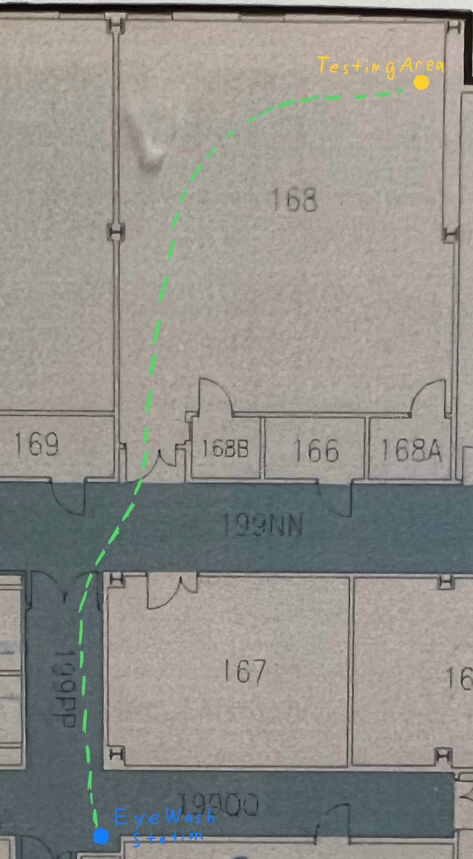

Fig 7. Testing location (yellow dot) and nearest Emergency Eyewash Station (blue dot).

* Using eye protection, a pair of UVEX clear lens Z87/Z94.3 rated safety goggles were sourced and located at/with the testing station for use by any group member when performing measurements.
* A 3D-printed enclosure was designed and made for testing in case of a catastrophic failure of any of the capacitors once we started using procedures to artificially age them.
* Wear long pants and closed-toed shoes.

#### **4.2.3 Redesigning the Perfboard Setup**

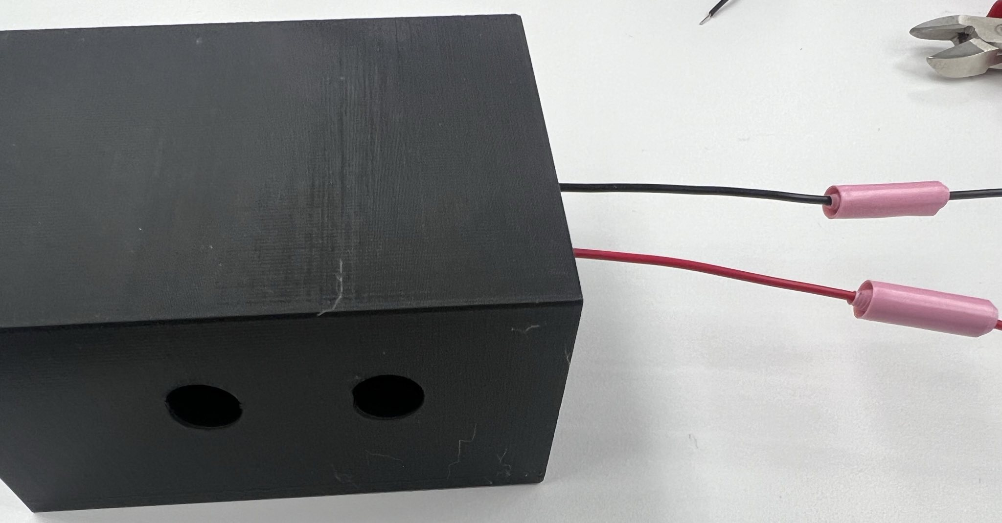

Figure 8: 3D-printed protective box with signal wires and probe ports.

Since our perfboard low-pass filter is relatively small, we designed a box, shown in Figure 8, that the perfboard can slide into and remain covered. The box shields us from any volatile reactions that may occur while still allowing access to our input signal and oscilloscope probes so that we can take measurements.

The box was designed in Solidworks to fit the perfboard that we have been using, and it took three design iterations to get everything sized and positioned correctly. The box was printed in PLA+ on a Prusa Mk3s+ printer with a 0.4 mm layer height.

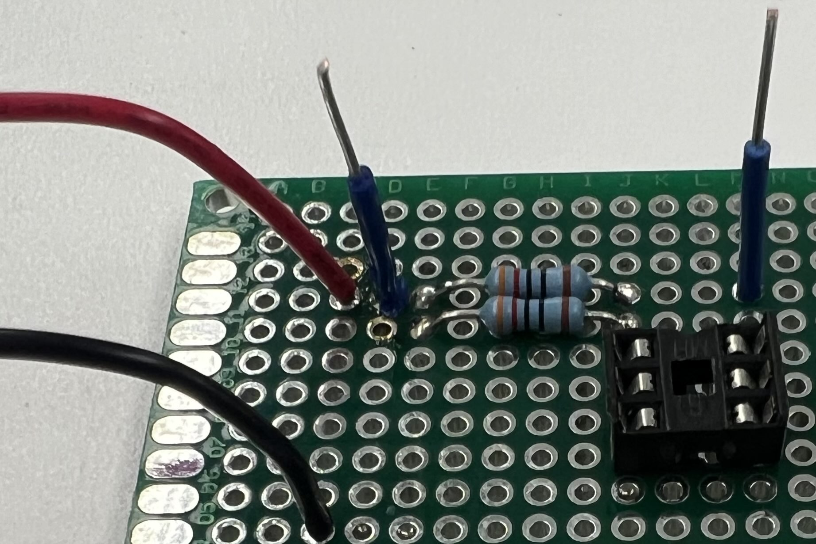

Figure 9: New test low-pass filter with IC socket and two blue wires for oscilloscope probes.

Once the final box design was printed, we assembled a new low-pass filter on a new perfboard to slide into the safety box, shown in Figure 9. This circuit was set up with an integrated circuit (IC) socket to allow us to change out the capacitor under test easily and to test multiple failure states.

### **4.3 Taking Measurements**

When taking our first measurements, we ran into issues with the output of the signal generator not reflecting our expected outputs. This was the result of the signal generator not being in High Z mode even though we believed at the time that we had set it up correctly for our experimentation and measurement purposes. Once we corrected this issue, the output signals accurately reflected our expectations, which we mentioned earlier in *Section 4.1.2 Building the Low-Pass Filter*.

One of the things that we needed to ensure whenever setting up the signal generator was that we had an appropriate DC offset to ensure that the minimum voltage of our input signal never went below 0 V. If our input signal went below 0 V, we can cause unintended damage to the capacitor currently under test. We wanted to avoid this risk because we maintain control of the health of the capacitors so that we can make reliable and accurate conclusions about how aging the capacitor affects its health without unknown interferences.

*Appendix A* covers the procedures for taking all measurements and ensuring that there is consistency across all tests/gathered measurements.

### **4.4 Developing the Model**

To create the RC low-pass filter model, we first chose our state-space model, and then we developed the state-space model.

#### **4.4.1 Choosing the State-Space Model**

We could represent our system in several ways: a transfer function, steady state analysis, or a state space model.

Analyzing our system as a simple transfer function allows for analysis of the transient behavior of the low-pass filter. However, a transfer function does not allow for analysis of a nonlinear system, and then it becomes less useful and insightful as systems become more complex. We did not desire to use a transfer function because we do not yet know how the aged capacitors behave and they may behave non-linearly or be very complex.

Alternatively, we could have simply performed steady-state analysis of the circuit and assumed a sinusoidal input. This approach is the quickest method as it requires no simulation but instead just some phasor calculations. Performing steady-state analysis was unappealing as we would prefer to not make assumptions about the input to the circuit and we are very interested in the transient response of the circuit, and this method of analysis tells us nothing about the transient response.

A state space model was the next simplest way to represent the circuit that gave us the relevant transient information. And was therefore chosen for our analysis.

#### **4.4.2 Developing the State-Space Model**

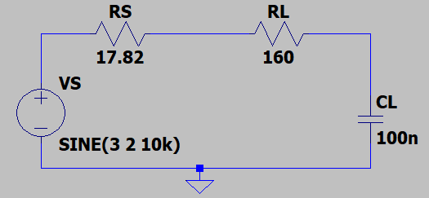

Figure 10: LTspice model of our low-pass filter circuit with an equivalent resistance of 160 Ω (RL), a 100 nF capacitor (CL), a source voltage (VS(t) = 3 + 2sin(2 * π * (10 kHz) * t) V), and a source resistance (17.82 Ω).

The state that represents this circuit in Figure 10 is very simple as there is only one element with memory: the capacitor.

|  |  | (6) |
| --- | --- | --- |
|  |  | (7) |
|  |  | (8) |

Equations (6) and (7) ic can be represented as (8).

|  |  | (9) |
| --- | --- | --- |
|  |  | (10) |
|  |  | (11) |

If we take VS to be u(t) and VC to be *x*1 then we get (9). Thus, resulting in (10), (11), and (12).

|  |  | (12) |
| --- | --- | --- |

The output, (12), is also very simple, as it is already the one component of the state.

### **4.5 Methodology of Failing Capacitors**

In order to develop our digital twin for future health monitoring, we need to build a database of capacitor health data. Once we have a collection of varying health data, we hope to be able to estimate the age of a capacitor based on capacitor characteristics that change through the aging process. We plan to track the capacitor failure conditions mentioned in *Section 3.3 Fail Conditions of Capacitors* for future use with health monitoring and failure prediction.

To build our capacitor health database, we need to artificially age capacitors and take measurements throughout the aging process at different lifecycle stages. The two capacitor aging techniques we plan to use are (1) subjecting the capacitor to heat levels higher than its rated heat (*see Appendix B*) and (2) applying a voltage across the capacitor that is higher than the capacitor’s rated voltage. As described in *Section 4.2.2 Safety Procedures*, we have developed specific safety procedures we will follow when executing the capacitor aging tests in order to ensure our safety as well as the equipment's safety.

## **5 Final Results**

Our main success from this semester was capturing experimental data from the low-pass filter and accurately timing it with our theoretical data from the state-space model.

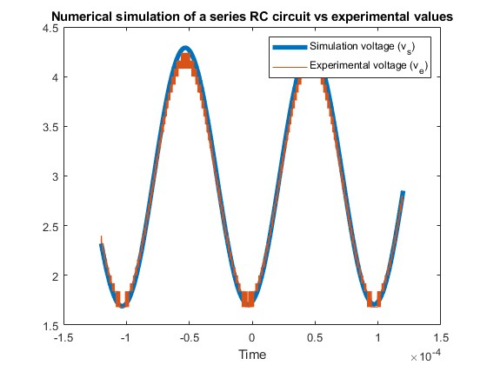

Figure 11: MATLAB voltage vs. time graph of unaged virtual twin capacitor voltage (blue line) synchronized to unaged experimental data capacitor voltage (orange line). RMS error calculated to be 77.9 mV.

Despite the volts per division being high, which causes a lower resolution of results, we can see that our experimental voltage is closely synchronized with our theoretical virtual twin voltage, as seen in Figure 11. To find the average difference between the experimental and theoretical data, we calculated the root mean squared (RMS) error to be 77.9 mV. This result shows that our experimental and theoretical data were not too far off from one another.

We have also developed an aging and test procedure for the capacitors as described in *Section 4.5 Methodology of Failing Capacitors*.

## **6 Future Work**

Throughout this semester, we have built a solid foundation of knowledge and understanding of the problem and our project setup, enabling us to develop a plan to further advance our work and make progress toward our goal in the next semester.

Over the J-term, we will begin to artificially age capacitors with the methods mentioned in *Section 4.5 Methodology of Failing Capacitors* and gather performance data on the aging capacitors at set intervals. We want to start aging the capacitors as soon as we can because we are unsure how long it will take to see the aging effects.

Throughout the spring semester, we want to develop digital twin state-space models of aged capacitors using the capacitor health database we will create from the age testing over the J-term. Then, we want to develop a method to estimate the age of capacitors by comparing experimental data to our state-space models. Finally, if we have remaining time, we want to rewrite our simulation programs in Rust, a low-level, memory-safe programming language, so that we can run the programs on a dedicated embedded system to monitor the system remotely.

We have created a set of ambitious goals, but we hope that we are able to achieve meaningful work throughout the rest of our senior capstone project experience.

## **7 Team Reflection**

While working on this project, we have developed a deeper understanding of several important lessons.

First, as engineers, we recognize that we have a responsibility to prioritize the safety, well-being, and quality of life of those that our work affects. We have a lot of power as people working to advance the future, so we must keep in mind what consequences our actions may bring. This responsibility requires that we prioritize ethical standards and public welfare over convenience or cost. By always being mindful of this responsibility and our actions, we can ensure that our work positively impacts the work around us.

We also recognize that the world is ever-changing and evolving. As engineers, we are at the forefront of technological development, so we will always need to stay knowledgeable of new advancements to continuously innovate and solve problems. We must be life-long learners and never lose that drive to understand more about the world around us.

Lastly, we recognize that in order to truly understand the needs of the world around us and the best way to address them, we must gain a broader education that extends beyond technical knowledge. By better understanding cultural, societal, and global contexts, we will be able to have a greater impact on the world around us. By expanding our knowledge, we hope to create solutions that not only satisfy technical requirements but also benefit humanity as a whole.

## **8 Conclusions**

Throughout this report, we identified what a digital twin is and how it would be useful in capacitor health monitoring. We completed research on our system under test, the RC low-pass filter, and our method of modeling, the state-space model. We explored our project process of building the low-pass filter, developing safety procedures, measuring data, and building the state-space model. We analyzed our results and planned our future work to further advance this project throughout the coming semester. We concluded with a reflection of our project work and how it will benefit our lives and future success as engineers.

## **References**

[1] J. Bofill, M. Abisado, J. Villaverde, and G. A. Sampedro, “Exploring Digital Twin-Based Fault Monitoring: Challenges and Opportunities,” in *Sensors*, Aug. 2023. [Online]. Available: https://www.mdpi.com/1424-8220/23/16/7087

[2] Lucy-Rukstales. “Twinning_for_Circuit_Failure.” GitHub.com. [Online]. Available: https://github.com/Lucy-Rukstales/Twinning_for_Circuit_Failure

[3] agrosjean0. “ECE448-VirtualTwinning.” GitHub.com. [Online]. Available: https://github.com/agrosjean0/ECE448-VirtualTwinning

[4] K. Laadjal, I. Jlassi, F. Bento, A.J.M. Cardoso. (July 2021). Online Condition Monitoring of Electrolytic Capacitors in DC-DC Interleaved Boost Converters, Adopting a Model-Free Predictive Controller. Presented at the 2021 IEEE 15th International Conference on Compatibility, Power Electronics and Power Engineering (CPE-POWERENG), Florence, Italy, 14–16 July 2021. [Online]. Available: https://www.researchgate.net/publication/353809071_Online_Condition_Monitoring_of_Electrolytic_Capacitors_in_DC-DC_Interleaved_Boost_Converters_Adopting_a_Model-Free_Predictive_Controller

[5] H. Soliman, H. Wang, F. Blaabjerg, “A Review of the Condition Monitoring of Capacitors in Power Electronic Converters,” IEEE Trans. Power Electron., vol. 52, no. 6, pp. 4976–49, Nov./Dec. 2016.

[6] “How does a RC Lowpass filter work?” Electrical Engineering Stack Exchange. [Online]. Available: https://electronics.stackexchange.com/questions/474131/how-does-a-rc-lowpass-filter-work

[7] “Passive Low Pass Filter.” ElectronicsTutorials. [Online]. Available: https://www.electronics-tutorials.ws/filter/filter_2.html

[8] “DEPARTMENT OF DEFENSE INTERFACE STANDARD AIRCRAFT ELECTRIC POWER CHARACTERISTICS AMSC N/A AREA SESS NOT MEASUREMENT SENSITIVE,” 2004. [Online]. Available: https://ieee.li/pdf/standards-handbooks/MIL-STD-704F.pdf

[9] “UKL2A0R1KDD,” DigiKey. [Online]. Available: https://www.digikey.com/en/products/detail/nichicon/UKL2A0R1KDD/2598554

[10] “MF1/4DCT52R3200F,” DigiKey. [Online]. Available: https://www.digikey.com/en/products/detail/koa-speer-electronics-inc/MF1-4DCT52R3200F/21679738

‌[11] R. D. MIDDLEBROOK and S. ĆUK, “A general unified approach to modelling switching-converter power stages,” *International Journal of Electronics*, vol. 42, no. 6, pp. 521–550, Jun. 1977, doi: https://doi.org/10.1080/00207217708900678.

‌

## 

## **Appendix A: Procedure for taking measurements of an electrolytic capacitor.**

Power on the function generator and oscilloscope to allow them to begin warming up, no measurements should be taken until they have been powered on for at least 5 minutes.

Taking the capacitor that is to be measured, place it in the testing rig ensuring that the grey line indicating which leg of the capacitor is the negative terminal is inserted into the negative side of the rig away from the resistors and probe attachment points.  
  
On the frequency generator, ensure that the following settings are loaded:

Frequency: 10 Kilohertz  
 Peak to Peak voltage: 4 volts

DC offset: 3 volts  
 Output mode: High Z

Ensure that the oscilloscope is set up and connected to its probe points.

Have a USB drive inserted into the front USB port of the oscilloscope to take a screenshot of the waveform that is being seen as well as either capturing a CSV file of the waveform or capturing it via MATLAB on the Intel NUC that the oscilloscope is attached to as detailed in the user manual.

Turn on the signal from the function generator by pressing the channel output button above the wiring for the channel that is being used.

Repeat for any additional capacitors that are to be tested/measured ensuring that no changes.

## 

## **Appendix B: Procedure for artificially aging an electrolytic capacitor with heat.**

Based on the datasheets for the capacitors [9], they should be able to maintain their rated values for 1000 hours at 105 °C and can be stored at up to 85 °C for 1000 hours without causing any degradation. To artificially age them with heat, we will be subjecting them to 170 °C for 1000 hours with periodic stopping points to take measurements of how they are performing.  
  
After following the testing procedures to take an initial set of measurements for the capacitors, they will be loaded into some test tubes to contain any off-gassing that occurs from them and loaded into the Infrared IC heater for 100 hours at 170 °C.

After 100 hours, the capacitors should be removed and new measurements taken, following the measurement procedures in Appendix A.  
  
This will then be repeated 9 more times with measurements being taken every 100 hours to build a set of baselines for capacitor ages across multiple different potential ages and should allow for a more accurate model to be built.